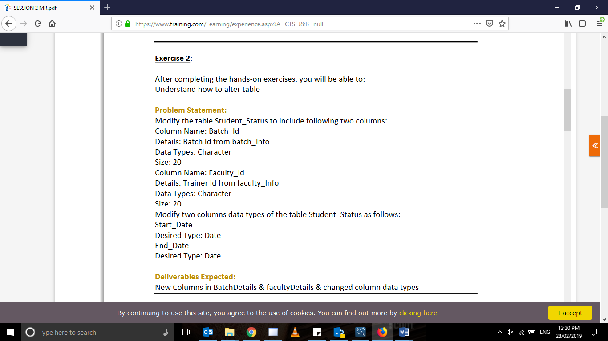

alter table student_status add batch_id varchar(20);

alter table student_status add faculty_id varchar(20);

alter table student_status modify start_date date;

alter table student_status modify end_date date;

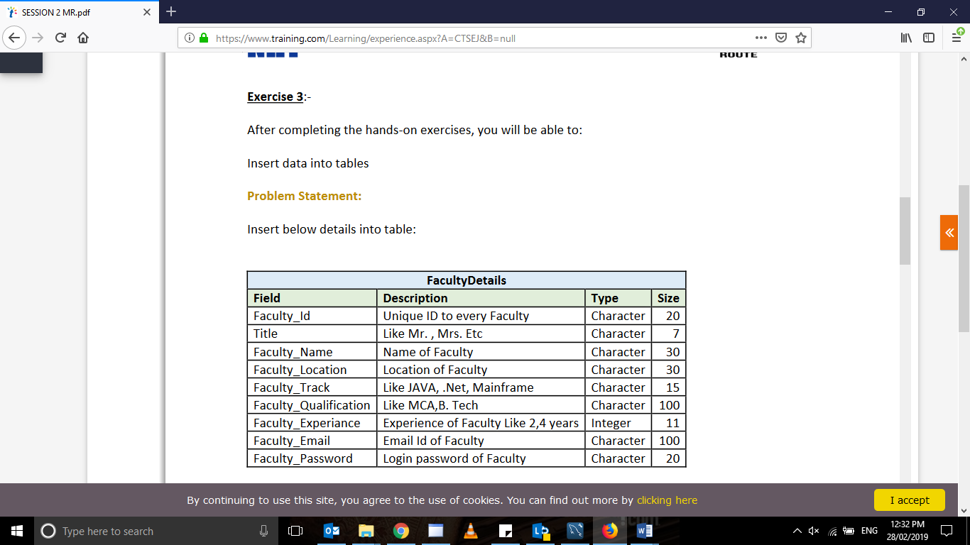

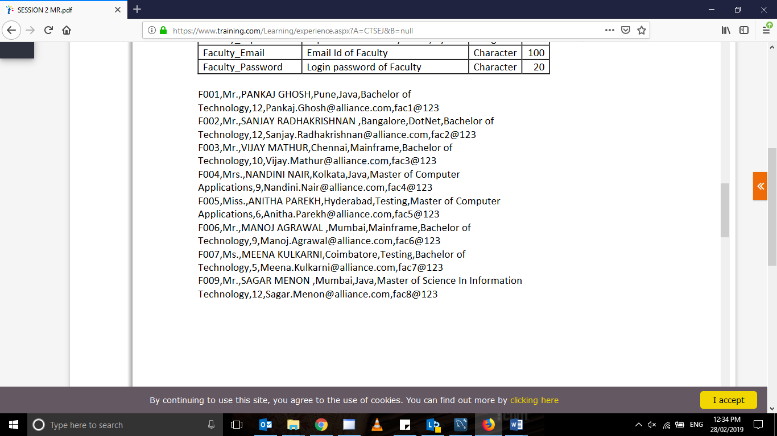

insert into Facultydetail values

('F001','Mr','Pankaj Ghosh','Pune','Java','Bachelor of technology',12,'Pankaj.Ghosh@alliance.com','fact@123'

);

insert into Facultydetail values

('F002','Mr','Sanjay Radhakrishnan','Bangalore','Dot net','Bachelor of technology',12,'Sanjay.Radhakrishan@alliance.com','fac2@123');

insert into Facultydetail values

('F003','Mr','Vijay Mathur','Chennai','Main frame','Bachelor of technology',10,'Vijay.mathur@alliance.com','fac3@123');insert into Facultydetail values

('F004','Mrs','Nandini nair','Chennai','java','Master of Computer Applications',9,'nandini.nair@alliance.com','fac4@123');

insert into Facultydetail values

('F005','Miss','Anita parekh','Hyderabad','Testing','Master of Computer Applications',6,'Anita.parekh@alliance.com','fac5@123');

insert into Facultydetail values

('F006','Mr','Manoj aggarwal','Mumbai','Main frame','Bachelor of technology',9,'Manoj.aggarwal@alliance.com','fac6@123');

insert into Facultydetail values

('F007','Mr','Meena kulkarni','Coimbatore','Testing','Bachelor of technology',5,'Meena.kulkarni.com','fac7@123');

insert into Facultydetail values

('F009','Mr','Sagar menon','Mumbai','java','Master of science in information technology',12,'Sagar.menon@alliance.com','fac8@123');

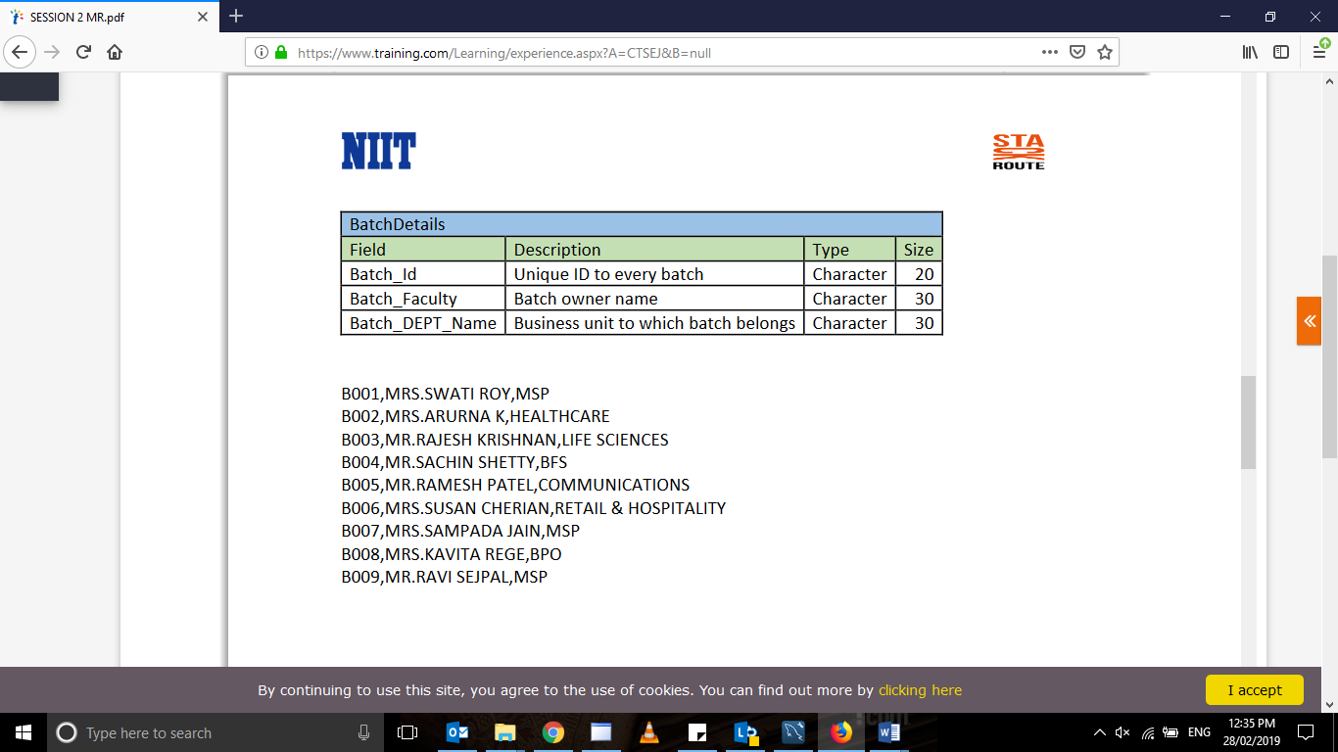

insert into batchdetail values

('B001','Mrs.Swati Roy','MSP');

insert into batchdetail values

('B002','Mrs.Aruna K','Health Sciences');

insert into batchdetail values

('B003','Mr. Rajesh Krishnan','Life Siences');

insert into batchdetail values

('B004','Mrs.Sachin Shetty','BFS');

insert into batchdetail values

('B005','Mrs.Ramesh Patel','Communications');

insert into batchdetail values

('B006','Mrs.Susan cherain','Retail & Hospitality');

insert into batchdetail values

('B007','Mrs.Sampada Jain','MSP');

insert into batchdetail values

('B008','Mrs.Kavita Rege','BPO');

insert into batchdetail values

('B009','Mrs.Ravi Sejpal','MSP');

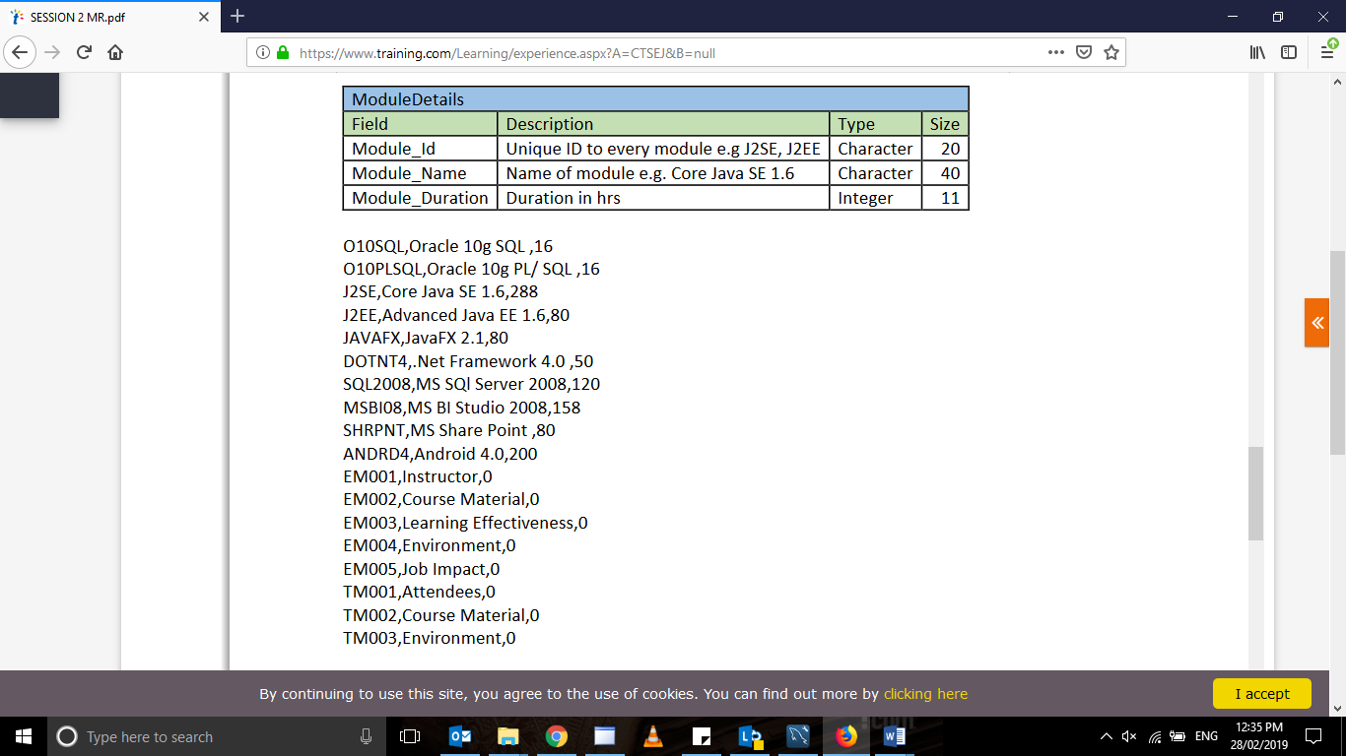

insert into moduledetails values

('010PLSQL','Oracle 10 g PL/SQL',16);

insert into moduledetails values

('J2SE','Core java Se 1.6',288);

insert into moduledetails values

('J2EE','Advanced Java EE 1.6',80);

insert into moduledetails values

('JavaFX','Java FX 2.1',80);

insert into moduledetails values

('Dotnet4','Net framework 4.0',50);

insert into moduledetails values

('SQL2008','MS SQL Server 2008',120);

insert into moduledetails values

('MSB108','MS BI studio 2008',158);

insert into moduledetails values

('SHRPT','MS sharepoint',80);

insert into moduledetails values

('ANDRD4','Android 4.0',200);

insert into moduledetails values

('EM001','Instructor',0);

insert into moduledetails values

('EM002','Course Material',0);

insert into moduledetails values

('EM003','Learning Effectiveness',0);

insert into moduledetails values

('EM004','Environment',0);

insert into moduledetails values

('EM005','Job impact',0);

insert into moduledetails values

('TM001','Attendees',0);

insert into moduledetails values

('TM001','Course Material ',0);

insert into moduledetails values

('TM003','Environment',0);

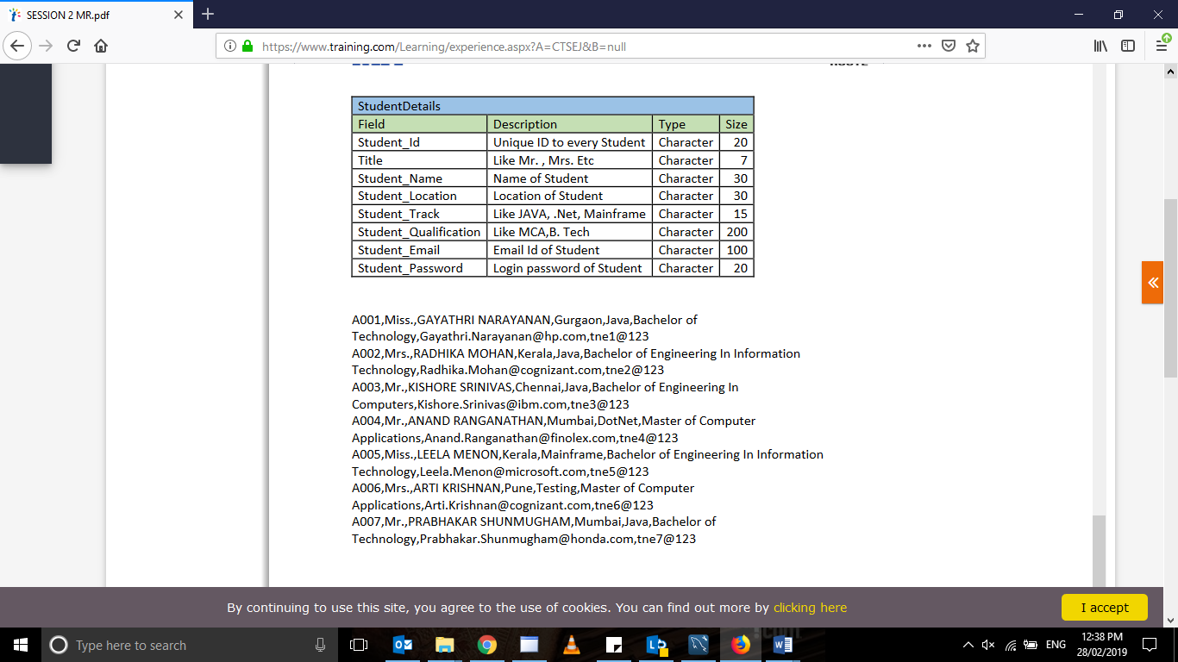

insert into studentdetails

values('A001','Miss','gayatri narayan','gurgaon','java','btech','gayatri@hp.com','tne1@123');

insert into studentdetails

values('A002','Mrs','radhika mohan','kerala','java','BE in IT','radha@cognizant.com','tne2@123');

insert into studentdetails

values('A003','Miss','kishore srinivas','chennai','java','BE in CS','srinivas@ibm.com','tne3@123');

insert into studentdetails

values('A004','Mr','anand ranganathan','mumbai','.net','master CA','anand@finolex.com','tne4@123');

insert into studentdetails

values('A005','Miss','leela menon','kerala','mainframe','BE in IT','leela@Microsoft.com','tne5@123');

insert into studentdetails

values('A006','Mrs','arti krishnan','pune','testing','master CA','arti@hp.com','tne6@123');

insert into studentdetails

values('A007','Mr','prabhakar shanumugham','mumbai','java','btech','prabhakar@honda.com','tne7@123');

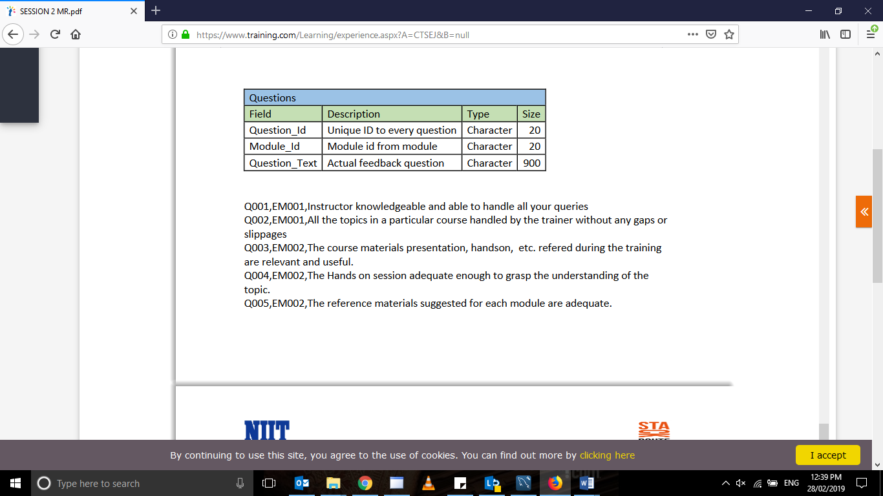

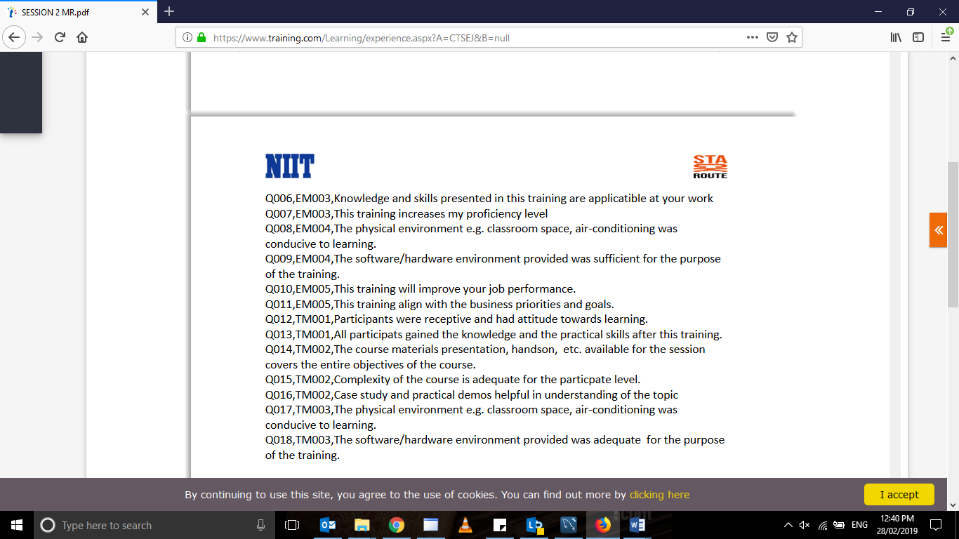

insert into questions values

('Q001','EM001','Instructor knowlegdable and able to handle all the queries');

insert into questions values

('Q002','EM001','All the topics in a particular course handled by the trainer without any gaps or slippages');

insert into questions values

('Q003','EM002','The course material presentation ,handson etc referred during the training are relevent and useful');

insert into questions values

('Q004','EM002','The handson session adequate enough to grasp the understanding of the topic');

insert into questions values

('Q005','EM002','The reference material suggested for each module are adequate');

insert into questions values

('Q006','EM003','Knowledge and skills presented in this training are applicable at your work');

insert into questions values

('Q007','EM004','This training increases my proficiency level');

insert into questions values

('Q008','EM004','The physical environment eg classroom space,air conditioning was conducive to training');

insert into questions values

('Q009','EM004','The software and hardware environment provided was sufficient for the purpose of training');

insert into questions values

('Q010','EM005','This training will improve your job performance');

insert into questions values

('Q011','EM005','this training align with the business priorities and goals');

insert into questions values

('Q0012','TM001','Participants were recieptive and had attitude towards learning');

insert into questions values

('Q013','TM001','The particiopants gain the knowlegde and the practical skills after the training');

insert into questions values

('Q014','TM002','The course material presentation,handson,etc available for the session covers the entire objective of the course');

insert into questions values

('Q015','TM002','Complexity of the course is adequate for the participate level');

insert into questions values

('Q016','TM002','Case study and practical demos helpful in understanding of the topic');

insert into questions values

('Q017','TM003','Physical environment eg. classroom space,air conditioning was conducive to learning');

insert into questions values

('Q018','TM003','The software and hardware environment provided was sufficient for the purpose of training');

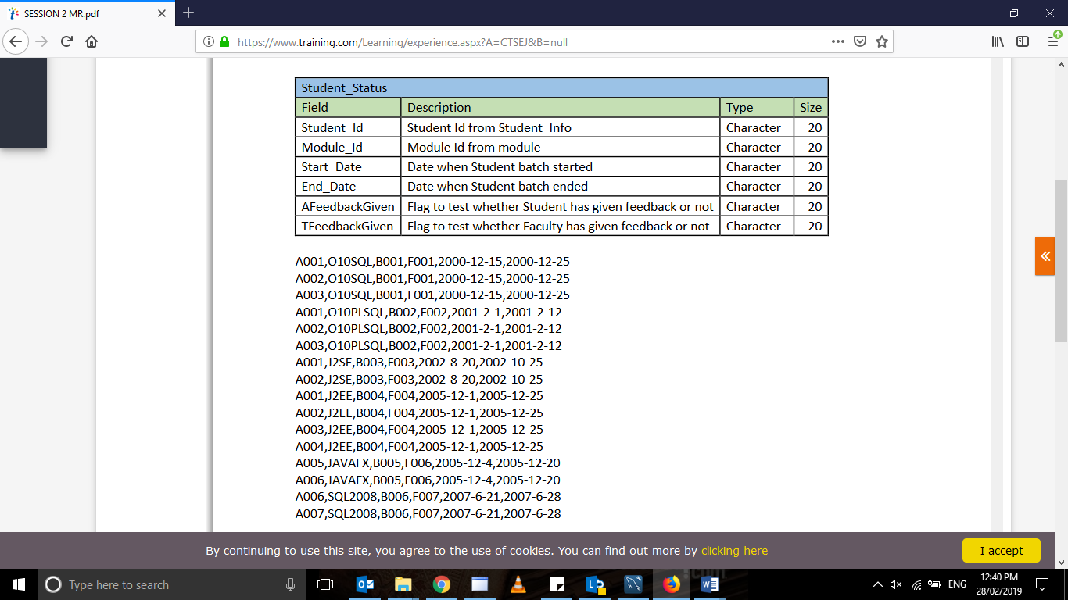

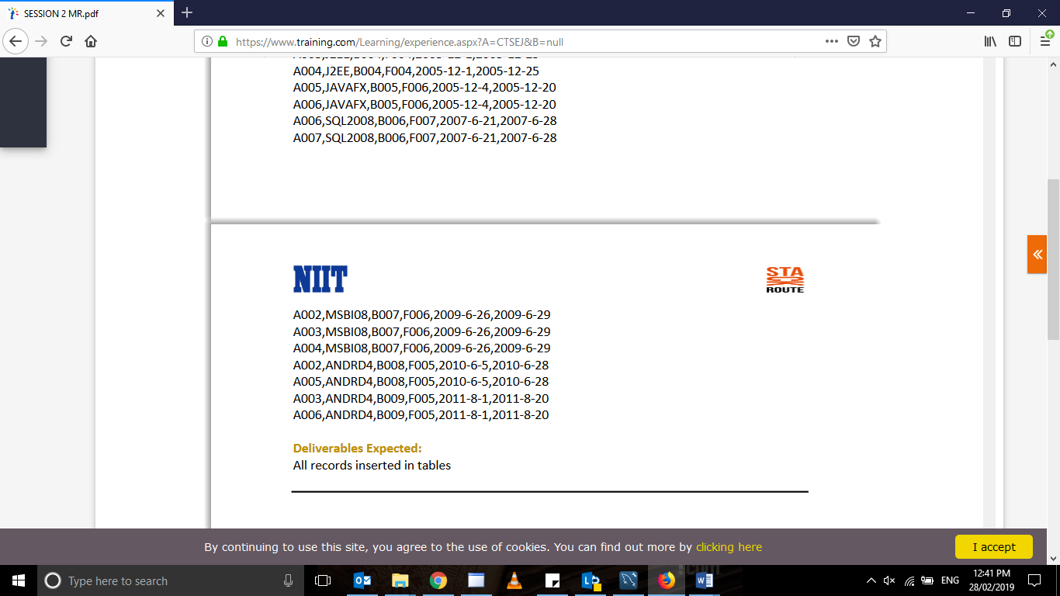

Insert into student_status values(‘A001’,’010SQL’,’2000-12-15’,’2000-12-25’,’B001’,’F001’,null,null);

Insert into student_status values(‘A002’,’010SQL’,’2000-12-15’,’2000-12-25’,’B001’,’F001’,null,null);

Insert into student_status values(‘A003’,’010SQL’,’2000-12-15’,’2000-12-25’,’B001’,’F001’,null,null);

Insert into student_status values(‘A001’,’010PLSQL’,’2001-2-1’,’2001-2-12’,’B002’,’F002’,null,null);

Insert into student_status values(‘A002’,’010PLSQL’,’2001-2-1’,’2001-2-12’,’B002’,’F002’,null,null);

Insert into student_status values(‘A003’,’010PLSQL’,’2001-2-1’,’2001-2-12’,’B002’,’F002’,null,null);

Insert into student_status values(‘A001’,’J2SE’,’2002-8-20’,’2002-10-25’,’B003’,’F003’,null,null);

Insert into student_status values(‘A002’,’J2SE’,’2002-8-20’,’2002-10-25’,’B003’,’F003’,null,null);

Insert into student_status values(‘A001’,’J2EE’,’2005-12-1’,’2005-12-25’,’B004’,’F004’,null,null);

Insert into student_status values(‘A002’,’J2EE’,’2005-12-1’,’2005-12-25’,’B004’,’F004’,null,null);

Insert into student_status values(‘A003’,’J2EE’,’2005-12-1’,’2005-12-25’,’B004’,’F004’,null,null);

Insert into student_status values(‘A004’,’J2EE’,’2005-12-1’,’2005-12-25’,’B004’,’F004’,null,null);

Insert into student_status values(‘A005’,’JavaFX’,’2005-12-4’,’2005-12-20’,’B005’,’F006’,null,null);

Insert into student_status values(‘A006’,’JavaFX’,’2005-12-4’,’2005-12-20’,’B005’,’F006’,null,null);

Insert into student_status values(‘A006’,’SQL2008’,’2007-6-21’,’2007-6-28’,’B006’,’F007’,null,null);

Insert into student_status values(‘A007’,’SQL2008’,’2007-6-21’,’2007-6-28’,’B006’,’F007’,null,null);

Insert into student_status values(‘A002’,’MSB108’,’2009-6-26’,’2009-6-29’,’B007’,’F006’,null,null);

Insert into student_status values(‘A003’,’MSB108’,’2009-6-26’,’2009-6-29’,’B007’,’F006’,null,null);

Insert into student_status values(‘A004’,’MSB108’,’2009-6-26’,’2009-6-29’,’B007’,’F006’,null,null);

Insert into student_status values(‘A002’,’ANDRD4’,’2010-6-5’,’2010-6-28’,’B008’,’F005’,null,null);

Insert into student_status values(‘A005’,’ANDRD4’,’2010-6-5’,’2010-6-28’,’B008’,’F005’,null,null);

Insert into student_status values(‘A003’,’ANDRD4’,’2011-8-1’,’2011-8-20’,’B009’,’F005’,null,null);

Insert into student_status values(‘A006’,’ANDRD4’,’2011-8-1’,’2011-8-20’,’B009’,’F005’,null,null);

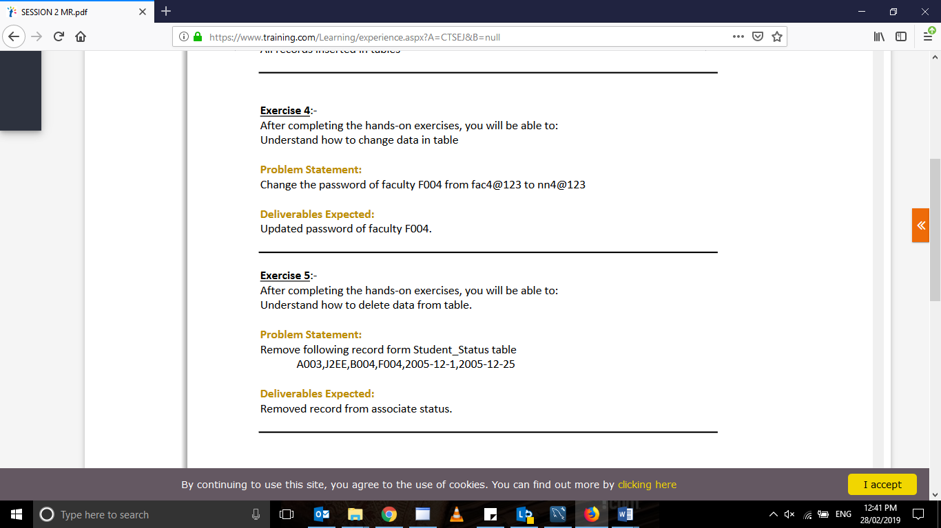

Question 4 –

update facultydetail set faculty_password = 'nn4@123' where faCulty_id ='F004';

Question 5-

Delete from student_status where student_id = ‘A001’ and module_id = ‘J2EE’;

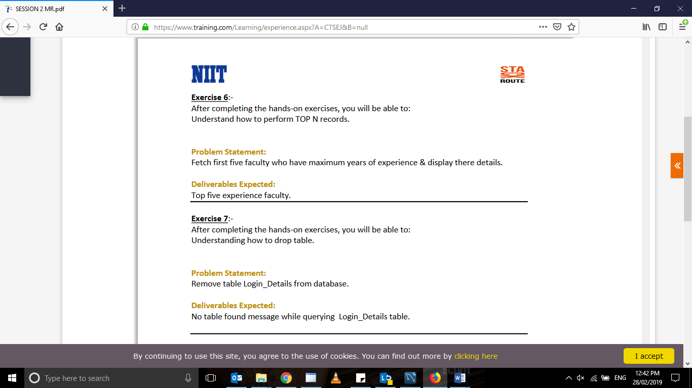

select * from facultydetail where faculty_experience >5;

drop table login_details;